Reference Number: RSRM-PA-2017-10

Patent Application

Resonation of Large and Arbitrary Shaped Objects

Summary
A new and unique method for the production of fully optimized spatial and wideband frequency resonation in arbitrary shaped objects of metal or other hard materials i.e. glass, ceramics, composites, including solid objects containing or in contact with liquids. The method employs a “special metal based resonator” which is custom designed for specific arbitrarily shaped objects. When mechanically joined to the object then the resulting “resonator/object” item acquires a new overall and optimized natural resonant frequency, including associated frequency harmonics that present natural resonant modes of the resulting “resonator/object” item under vibrations. In addition, MMM (see “EP 1 238 715 A1, Multi-frequency ultrasonic structural actuator”) introduces the necessary spectral complexity to enable an ultrasonic driving (or carrier) signal, to extend its spectral content. This induces spatial vibration in every possible resonant mode within the “resonator/body” item.
The custom designed resonator is optimized to operate at a certain isolated and fixed resonant frequency, meaning that the resonator will operate at its own natural resonant frequency or natural resonant vibrating mode (for instance, producing either axial or longitudinal, or radial, or bending and torsional vibrations). When such a customized resonator is mechanically joined to an arbitrary shaped solid body (resulting in a “resonator/object” item), it will still be able to operate at its own natural resonant frequency. However, since it is rigidly and acoustically coupled with another solid body, it will acquire or couple with the specific natural resonant modes of the arbitrary shaped body. Consequently, a new resulting “frequency spectrum” of the described mechanical joined “resonator/object” will have a number of natural resonant frequency modes.
The customized resonator will be vibrated at its dominant, natural resonant mode (or on its carrier frequency). At the same time MMM signal modulation (“EP 1 238 715 A1, Multi-frequency ultrasonic structural actuator”) will be applied accordingly, thus enabling the customized resonator to excite many other natural resonant modes (or harmonics) belonging to the other solid body, or effectively belonging to the mechanical system “resonator/object”.
The method combines a “special and customized mechanical resonator design” being an external vibrating mode transformer, which enables the object’s natural resonance frequency and the added-resonator’s natural resonance frequencies to be combined into a new and unique overall natural resonance frequency. The mentioned combination of an external custom-designed resonator (or vibrating-mode transformer) and object, to be ultrasonically treated, can be realized through mechanical fixation of externally fixed ultrasonic converter, directly on the customized resonator, by Welding and/or Bolting, or bespoke Clamping Systems. This way resonant vibrating regimes can be introduced, facilitated and realized efficiently in almost any solid body, or bodies containing or in contact with fluids. Furthermore, the method enables the possibility to vibrate “extreme large” objects by employing multiple “Special Metal Based Resonator” units which are tuned to be harmonic with respect to their individual effects. The resulting system can be employed as a continuous agitation system or as an intermittent agitation system which can be installed as a “stand-alone” and fully automatic agitation system.

Description

The traditional and state of art method for ultrasonic agitation of solid objects is to design assuming that all sections, elements or parts of such objects to have the same, “natural resonant frequency”. This is however only possible for simple geometry objects. Such “mutually frequency-tuned resonating objects” in ultrasonic engineering have names such as: Ultrasonic Converters, Boosters, and Sonotrodes.
Large and arbitrary shaped solid objects (such as reactors, vessels, platforms, bridges, ships and other large steel structures) usually have a number of “natural resonant frequency modes”, so a desired, single, isolated and well-defined resonant frequency mode is normally not available. The described method now allows for the complete and coherent vibration of such mentioned arbitrary shaped objects.
There are many real issues and associated problems with large and arbitrary shaped objects and structures in today’s environment. They span from corrosion or failure of metal structures due to residual stresses to surface fouling and solids build-up on process and transportation equipment. The enablement of “complete agitation of large arbitrary objects” now allows for the relatively simple utilization of proprietary “MMM” based ultrasonic technology solutions for applications such as:
- Stress relief in large structures such as bridges, platforms, pipelines, heat exchanges
- Enhancement or mitigation of biological and chemical reactions in large vessels and reactors
- Processing of liquids in large process vessels, pipes, containers and metal / glass / composite surfaces
- Descaling of large pipes, reactors, heat exchangers, vessels
- Resonation of large marine vessels, harbor installations, offshore platforms and pipelines for prevention of algae formation
- Prevention of fouling in large fluid filled pipelines and associated equipment

There are many industries which suffer from issues and problems such as those mentioned above. Civil Engineering, Process Industries, Marine and Mechanical Engineering sectors are all effected by “residual stress” and the means of removing such stresses so as to mitigate corrosion and early structural failure. “Ultrasonic Peening” is now enabled and traditional methods can be replaced through the new method. The Food, Chemical, Pharmaceutical, Marine, Energy and Environmental sectors all have problems to a large degree regarding descaling, fouling and unwanted materials build on large process and transportation surfaces. Complete ultrasonic vibration of large and arbitrary parts and structures now enables mitigation of such materials build-up. The Food, Chemical, Pharmaceutical and Environmental sectors are all searching for new and innovative methods to promote faster and more efficient reaction processes. Through the new ultrasonic method, large reaction and process system efficiency may be enhanced, due to increased particle / molecule contact, larger reaction contact surface areas.

Claims
- The creation of fully optimized spatial and wideband frequency resonation in arbitrary shaped objects of hard materials such as glass, ceramics, polymers and composites.

- The creation of the resonance according to claim 1. is characterized in that: a coupled metal “resonator & actuator” device is vibrated at its combined and dominant, natural resonant mode (or on its carrier frequency) to produce unique and optimal vibrations in the form of torsional, axial and radial vibrational modes.

- The coupled metal resonator & actuator device according to claim 2. is characterized in that: the “resonator & actuator” device then transfers and shares it`s vibrations with the arbitrary shaped object

- The coupled metal resonator & actuator device according to claim 2. is characterized in that: the ultrasonic metal resonator part of the “resonator & actuator” device is custom designed specifically and according to the arbitrarily shaped object under consideration in order to be rigidly fixed and acoustically coupled to the object under consideration.

- The combined metal resonator & actuator device according to claim 2. is characterized in that: the ultrasonic actuator part of the device uses signals generated from a special and proprietary ultrasonic power generator (Multifrequency, Multimode, Modulated Sonic and Ultrasonic Generator; EP 1 238 715 A1).

- The combined resonator & actuator device according to claim 2. is characterized in that: the ultrasonic metal “resonator & actuator” device is mechanically coupled to the arbitrarily shaped object and vibrations are transferred spatially-homogeneously throughout the arbitrary object.

- The custom designed ultrasonic metal resonator according to claim 4. is characterized in that: the ultrasonic metal resonator part of the device has a custom design which is optimized using Finite Element Analysis and other similar types of modelling and interrogation of that arbitrary object.

- The mechanical coupling according to claim 6. is characterized in that: the resonator & actuator device is coupled to the arbitrarily shaped object by means of welding, bolting, clamping or a customized bracing fixture.

- The mechanical coupling according to claim 6. is characterized in that: there may consist a multiple of “Special Metal Based Resonator” units which are specially interconnected and are tuned to be harmonic with respect to their individual effects, this resulting in a considerable increase in overall agitation effectiveness, especially for extremely large objects.

- The multiple of “Special Metal Based Resonator” units according to claim 9. is characterized in that: They may be employed as a means of effectively agitating large or extremely large objects in both continuous or intermittent operation.

- The multiple of “Special Metal Based Resonator” units according to claim 9. is characterized in that: large or extremely large object can be agitated under either manual or automatic mode.

- the resonator & actuator device is coupled to the arbitrarily shaped object by means of welding, bolting, clamping or a customized bracing fixture.

Sketches

Fig 1 Fig 2

Fig 3 Fig 4

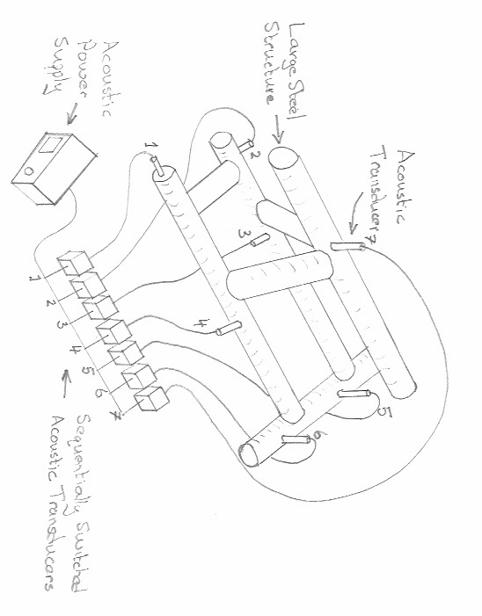

Fig 1 = Side view showing large reactor with Clamp-on “Resonator / Actuator” assembly
Fig 2 = Opposing side view of large reactor with Clamp-on “Resonator / Actuator” assembly
Fig 3 = 3D computer simulation of resulting full ultrasonic vibration distribution on large reactor
Fig 4 = A multiple of “Special Metal Based Resonator” units working in continuously or intermittently and under manual or automatic mode

